Session 4 -1

import java.util.HashMap;

class Solution {
public int lengthOfLongestSubstring(String s) {
if (s == null || s.length() == 0) {
return 0;
}

int maxLength = 0;
int left = 0;

// Map to store the last seen index of each character
HashMap<Character, Integer> charMap = new HashMap<>();

for (int right = 0; right < s.length(); right++) {
char currentChar = s.charAt(right);

// If the character is already in the map and within the current window
if (charMap.containsKey(currentChar)) {
// Move the left pointer forward to avoid duplicates
left = Math.max(left, charMap.get(currentChar) + 1);
}

// Update or insert the character's most recent position
charMap.put(currentChar, right);

// Update the maximum length found so far
maxLength = Math.max(maxLength, right - left + 1);
}

return maxLength;
}
}

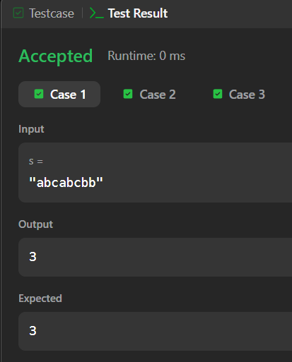

Session 4 - 2

import java.util.ArrayList;
import java.util.List;

class Solution {
public List<String> findAndReplacePattern(String[] words, String pattern) {
List<String> result = new ArrayList<>();

for (String word : words) {
if (matches(word, pattern)) {
result.add(word);
}
}

return result;
}

private boolean matches(String word, String pattern) {
// Maps pattern character to word character
char[] pToW = new char[26];
// Maps word character to pattern character
char[] wToP = new char[26];

for (int i = 0; i < pattern.length(); i++) {
char pChar = pattern.charAt(i);
char wChar = word.charAt(i);

int pIdx = pChar - 'a';
int wIdx = wChar - 'a';

// Check mapping from pattern to word
if (pToW[pIdx] == 0) {
pToW[pIdx] = wChar;
} else if (pToW[pIdx] != wChar) {
return false;
}

// Check mapping from word to pattern
if (wToP[wIdx] == 0) {
wToP[wIdx] = pChar;
} else if (wToP[wIdx] != pChar) {
return false;
}
}

return true;
}
}

